The human body continually inspires,
and allows for, creation in the arts.
Art and the human body and inextricably linked.
In this unit we will explore the many relationships between the human body and a variety of art forms by looking at human physiology, through the examination of the work and methods of a variety of artists, as well as by exploring our own artistic process in relation to the topic.
Task A: Research Component
Research a component of the human body which allows for creation in your chosen art form. This might include a specific muscle group, anatomical feature, brain process, etc…
You must present your findings to the class, although the method of delivery is up to you. Videos, posters, power point presentations, Pecha Kucha^{tm} etc… are all appropriate.
No matter which format you choose to deliver your content, you must include the following:
- A selection of images of the body part / structure you have chosen. At least one of those images must be a clearly labelled anatomical image.
- A detailed description of HOW this body part or feature functions and how it is used to help create / appreciate in your art form. You may extend your discussion to other art forms, but focus mainly on how your part is used in your particular branch of the arts.
- ALL images and information sources must be properly cited/ labelled within the presentation or on the poster and a full bibliography in MLA style must accompany the work.
Task B: Creation
In the art form of your choice, create a piece of art, or a performance, which relates to the body part you researched. Consider exploring the range of functions of your body part, challenging the body part, adapting a body part to a new function, or communicating information about the body part via your creation.
The sky is the limit. Get creative and think outside of the box!
Unit Checklist – During the course of this unit you should complete:
- Initial thoughts brainstorming ⃝ ___________
- Proposal / outline: ⃝ ___________
- A minimum of 4 process journals ⃝ ___________
(See stencils in this package )
- Research Presentation in the format of your choice ⃝ ___________
- Original Creation ⃝ ___________
- Students working in groups must be able to clearly identify their individual contributions.
- Each student will write an individual Artist’s Statement (See outline at the back of this package)

In ALL components of your work, your resources MUST be clearly indicated.

When doing your research, record every source which informs your understanding of the topic, even if you are not quoting the source directly. Record as many of the following items as possible:

Author’s name example: John Doe
Title of the publication or website Dancing for Deer
Title of the article or section of a website Put your right foot in.
Publisher Forest Publications
Publication date or most recent update (web) Jan 2011(use n.d for no date)
Publication location for items in print, URL for web www.dfd.com
Date retrieved from online sources Sept. 12. 2013

For our example the bibliographical citation would read:

Doe, John. “Put your right foot in.” Dancing for Deer. Forest Publications. Jan 2011. www.dfd.com. Retrieved Sept. 12, 2013.

Process Logs – 4 stencils are provided. Please continue to use this format
of response for each working session.
Session 1:
What did I do?
What went well?
What was a struggle?
What feedback was I given & from who?
What is my plan for next time?

Session 2:
What did I do?
What went well?
What was a struggle?
What feedback was I given & from who?
What is my plan for next time?
Session 3:
What did I do?
What went well?
What was a struggle?
What feedback was I given & from who?
What is my plan for next time?

Session 4:
What did I do?
What went well?
What was a struggle?
What feedback was I given & from who?
What is my plan for next time?

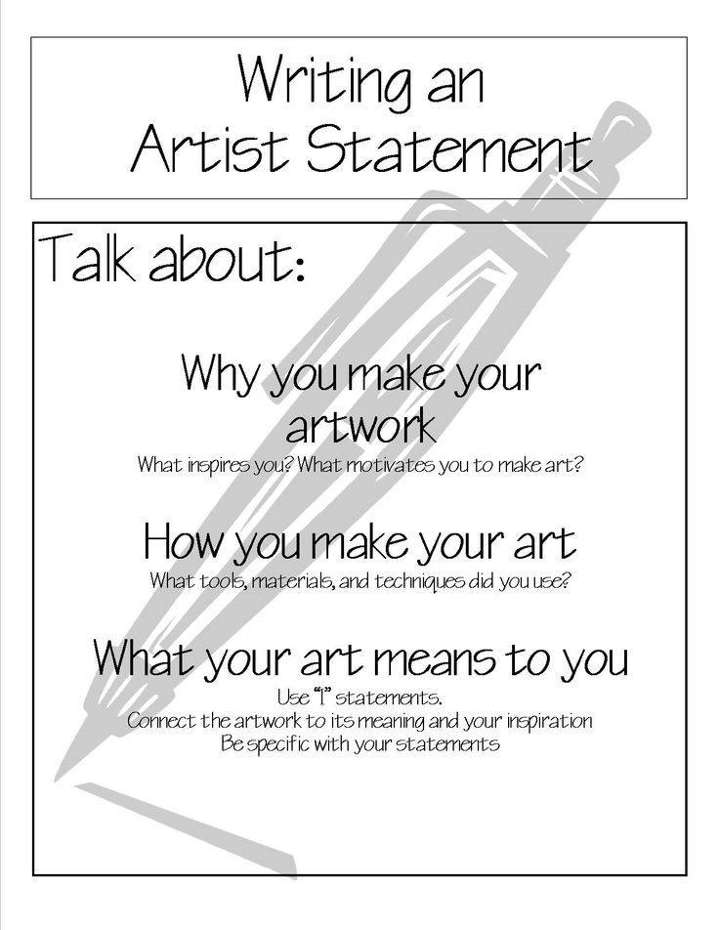

Although it is good to have an all-encompassing artist statement, for this assignment I would like you to create an artist’s statement which is specific to your Anatomy of Art creation.

Focus on:
~How your research, thoughts or experiences with your anatomical feature influenced
your creation.
~How you used the media or a combination of mediums to create.
~If you worked collaboratively you can comment on the process and final result.
~What do you hope the audience walks away with after viewing the piece?

Your statement should be ½ to 1 page in length
Artist’s Statement:
Title of the Artwork: ___________________________________
Medium:____________________________________________
Name;______________________________________________
Collaborators:________________________________________

__________________________________________________________________________________________________________________________________________________________________________________________________________________________________________________________________________________________________________________________________________________________________________________________________________________________________________________________________________________________________________________________________________________________________________________________________________________________________________________________________________________________________________________________________________________________________________________________________________________________________________________________________________________________________________________________________________________________________________________________________________________________________________________________________________________________________________________________________________________________________________________________________________________________________________________________________________________________________________________________________________________________________________________________________________________________________________________________________________________________________________________________________________________________________________________________________________________________________________________________________________________________________________________________________________________________________________________________________________________

