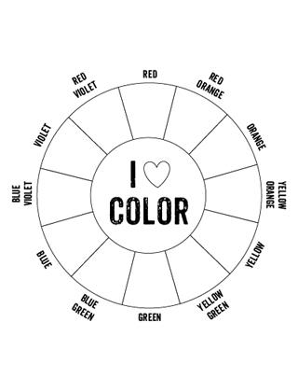

Colour Theory
Primary Colours – Cannot be made by mixing other colours

MAGENTA CYAN YELLOW
Secondary Colours – Created by mixing two primary colours

VIOLET GREEN ORANGE
Tertiary Colours- Created by mixing one primary and one secondary colour which are beside each
other on the colour wheel together

Complementary Colours – Colours directly across from each other on the colour wheel

Tint –
a colour with added white
( pink as a tint of red / magenta )
Shade –
a colour with added black
( Navy blue is a shade of blue )
Hue-
Every colour on the colour wheel is a hue and can be measured in degrees from 0° - 359°.
In art we often refer to hues when describing colours that are a mixture of two common colours so that whoever we are taking to has a better mental image of what the colour looks like. What we are really doing when we speak that way is describing the colour’s placement on the colour wheel.
ex. Fuschia is a hue of magenta that contains a lot of purple, or teal is a hue of green that is close to blue on the colour wheel

Colours Temperature - Colours can be divided into WARM and COOL colours
Warm colours are : Red, Orange, Yellow

Cool colours are: Purple, Blue, Green

Many colours have hues which can be considered to be warmer or cooler, especially purple and yellow which lie at the intersection of the cool and warm colours, ex. A purple that contains a lot of red is considered warmer while a purple containing mostly blue is considered to be cool.
‘Warm’ and ‘cool’ refer mainly to the symbolic and emotional nature of colours and the reactions we have to them. Red tones tend to feel angry, energetic, and physically warm (think fire, sunlight etc…)
Cool colours tend to feel calm, sad, and physically cold ( think shadows on snow or ice, water, etc…)
Colour Schemes
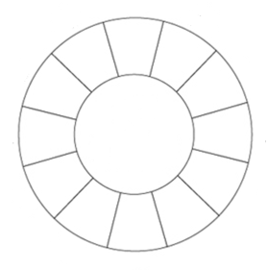
Colour schemes are specific groupings of colours. They can be used to create contrast, harmony, or to evoke a specific mood in decorating, design and of course art!
Monochromatic – mono (one) chroma ( colour) a monochromatic colour scheme is created by using one colour along with black and white to create tints and shades of the original colour. Art work created using a monochromatic colour scheme can be quite dramatic and is often effective in evoking emotions associated with the base colour.
Complimentary – colours directly across from each other on the colour wheel ( ex. Orange-Blue, Red-Green, Purple-Yellow ) These colour schemes are often associated with sports teams and or holidays because they are highly contrasted and make each other pop visually so they look great in logos, advertising, marketing, etc…
Split Complimentary – a colour + the two colours on either side of the first colour’s compliment
ex. Yellow + red-violet + red-orange
Analogous – analogous colours are colours that are next to each other on the colour wheel.
ex. Blue, Teal (blue-green) and green. Analogous colours are harmonious and generally pleasing to the eye.
Triadic (Triangle)– three colours which are equally spaced around the colour wheel. Using the three primary colours would be the simplest example of a triadic colour scheme.

Tetradic ( rectangular ) – four colours arranged into two complimentary pairs ex. Green – red, orange, blue
Assignment:
Draw or collage examples of each of the main colour schemes. You must DRAW at least THREE of the six. Label each drawing or image with the correct colour scheme name.

_______________________________ ________________________________

_______________________________ ________________________________

_______________________________ ________________________________
Using pencil only, draw a landscape that fills the box. Lightly draw a line down the middle.
Now, using pencil crayon, colour in one side with WARM colours and the other with COOL colours.

