Pixlr Exercise #1 – Kaleidoscope
This is an exercise to introduce you to many of the essential tools found in digital editing software such as Photoshop and Pixlr. It will also produce a funky piece of art!
To find copyright-free images for your work
go to:
Google Images >
tools >
usage rights >
select noncommercial reuse with modification

There are also quite a few specific sites for downloading copyright-free images such as
Pixabay.com, Lifeofpix.com and Pexels.com

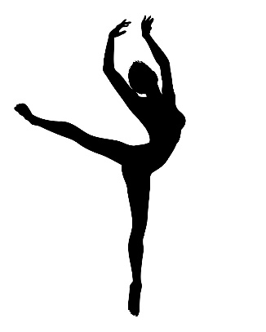
Step 1: Select and download 2 images – One will be the background, the other should be a silhouette
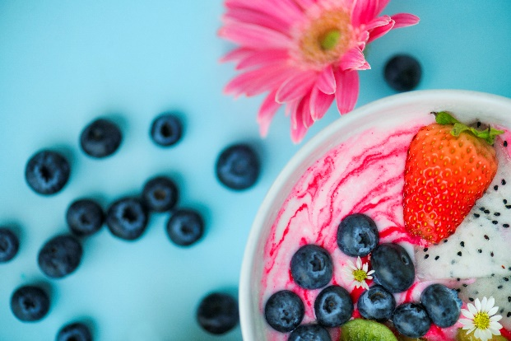

Important – Choose images that are not fully symmetrical for the best effect.
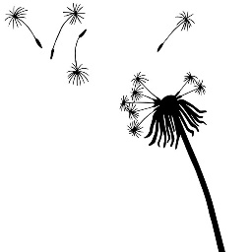
< This

Not This >

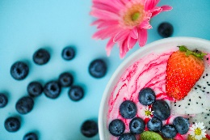
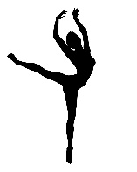
Step 2: Open a blank Word Document.
At the top of the document write
“PIXLR Exercise 1 Originals – Your Name”
Insert both of your original images.
Shrink them if needed so they fit on one page.
Save the page as “Exercise 1 – Your Name”
and upload it to Managebac.
Originals

Step 3:
Open Pixlr.com
( you may need to allow Flash to run! )
Create a new image which is 1500 x 1500 pixels
Check off Transparent
You can also name your document right away!
Call it “Exercise 1 – Your Name”

Step 4:
From the FILE menu at the top choose “Open image” and then select your background image from the folder where you saved it.
Using the Marquee tool,
draw a square or rectangle around the portion of your image that you find the most visually interesting. Make sure that there is plenty going on visually and not a ton of empty space.
When you are happy with your selection
Press ctrl+ C to copy the selection.
NOTE:
If it does not work with the ctrl code,
You can find the copy command under the EDIT drop down menu.

Step 5:
Minimize the background image window and click back onto the blank image you created earlier.
Press Ctrl+V to paste the selection you just copied onto the blank document.
Again, if the ctrl shortcut does not work you can find the paste command in the EDIT menu.

WAIT! It’s
WAYYYY too big!

Often the resolution of your image will differ from the document you are working on and your selection may be WAY bigger or WAY smaller than you expected. To resize the newly inserted image, go to the EDIT menu and select FREE TRANSFORM. Little blue squares will frame the selection and you can drag the corners to shrink or expand the image. If the image is really big, drag the corner inward a bit then click on the image and hold while dragging it so it is more centered on the canvas. Repeat until it is fully visible and no more than ¼ the size of the canvas.

Step 6:
Now you are going to duplicate the layer which has the image on it.
To do that, right click on the layer which holds
your image from the LAYERS navigation on the
right side of the screen. Select Duplicate Layer.
*** If the layer navigator is not there click on
the VIEW menu and select LAYERS to make it
appear ***
When working with layers imagine each one as a sheet of clear plastic with images printed on them. You can rearrange these layers independently from each other until you are happy with the composition.
Step 7:
Use the MOVE tool to reposition “Layer 1 copy”
Click on the LAYERS menu and click on Flip Horizontal or Flip Vertical to mirror your initial image.
Use the MOVE tool and or the arrow keys on your keyboard to do fine adjustments until your image lines up as precisely as possible.

Once you are happy with the
Alignment of your two layers
Right click on “Layer 1 copy” and select
“Merge Down”.

This will essentially glue the current layer
and the one below it together.
(In this case, Layer 1 copy + Layer 1)

Now you can repeat the duplicate + flip steps and your background will be complete!
Don’t forget to merge down once you align the 2 images so that you don’t end up with too many layers!

If you can still see the checkered background around your image you can do one of two things:
Use FREE TRANSFORM and drag the corners to the edge of the canvas
OR
Use the CROP tool – drag the selector to where you want to trim them press enter.
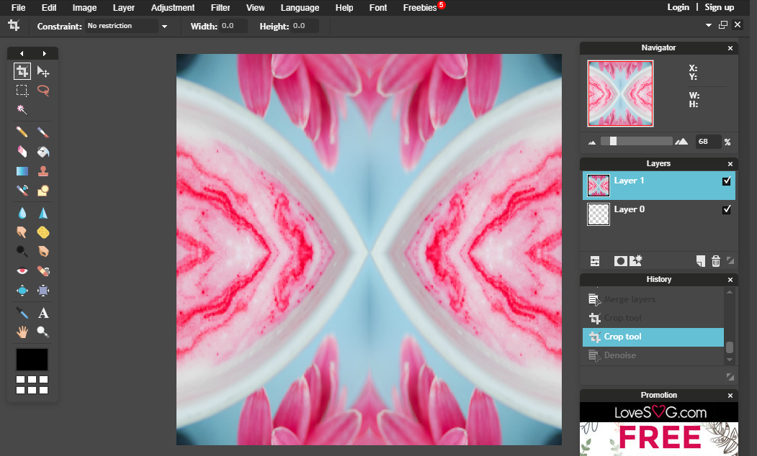

Congrats! You have made
your first digital collage!

Repeat the steps adding your silhouette image on top!

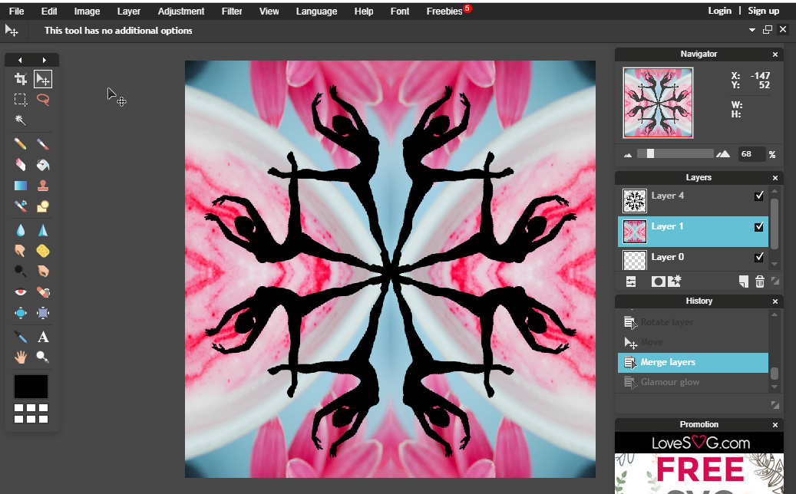

Be sure not to merge the silhouette layers to the background layers until the very end.
Once your silhouettes are in you can make changes to the background layer that way enhance the piece as a whole including adjusting colour and brightness, or even playing with filters!

Here are two examples -
Pixilate filter + saturation up Solarize function + Vignette filter + saturation
If you try out different things feel free to take screen shots and paste them into your Originals word doc as a record of your experimentation, just crop them so only the image shows like I have done here.
You can also save different versions of your image, just make sure you change the name each time
( v1. v2 etc. )
When you have decided on your final version save it as a PNG or JPEG image ( best quality ) and upload it to Managebac. Remember it should be called “Exercise 1 – Your name”

