Term 3 Sketchbook assignments – Part 1
Please choose 3 of the following activities to complete in your sketchbook.
The assignments may be completed in the actual sketchbook or on separate paper and then glued in ( a good idea if you decide to paint! )
Also, despite the word "sketch" in the name, these assignments are designed to help you build skills and as such, I am looking for well developed, nicely finished art works.
Option 1: Still life three ways
Media: You can use any media or combination of media for this option.
Place 3-5 objects in an interesting composition on a surface where you can view it from at least three different angles. Draw the composition from three different angles paying attention to how the shape of each object changes and how their relationship to each other shifts.
- Look at your object closely.
- Include lines and shading to communicate the form and texture of each object.
- Don’t forget to include any shadows cast by the objects.
You can draw the three views on one page BUT make sure that they fill the page and don’t just hide in the corner.
Option 2: Flip side
Media: Magazine or printed image + media of your choice
Cut an image in half ( horizontally, vertically or diagonally OR cut out a section of the image)
Complete the other side/ missing section with something new using the media(s) of your choice.
Try and create a juxtaposition ( contrast ) between the two parts –
light and dark, good and evil, polluted un-polluted, natural vs. unnatural / man-made, etc.
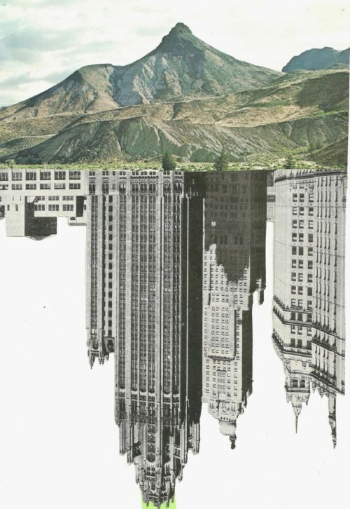
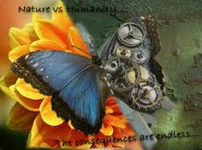

Option 3: Toon Time
Media: pencil to start, pen, ink, pencil crayon or marker for polished character
Create an original cartoon character.
Give it a name and appropriate clothing.
This article mentions some great things to consider when designing characters.
https://graphicmama.com/blog/cartoon-character-design-in-10-steps/
Feel free to do multiple sketches on your page to develop your character.
Colour in the one you like the most adding details and cleaning up the drawing.
Beside your drawing, or on the back, describe the character and give it a short back story.

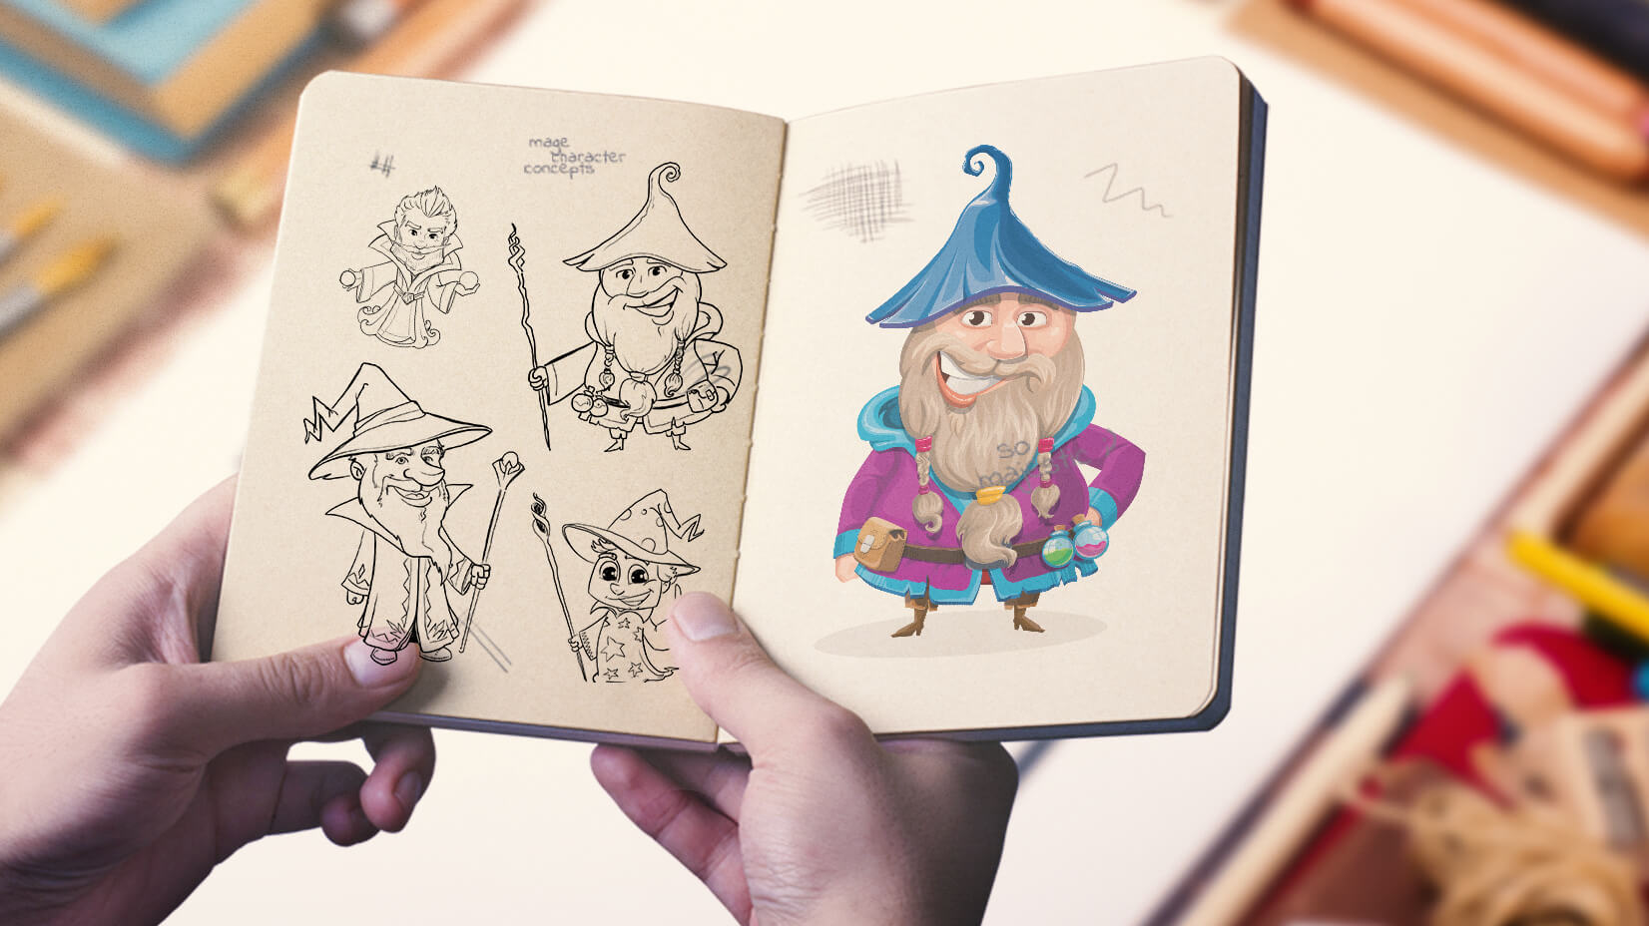

Option 4: Hybrid Animal
Media of your choice
Combine an animal with an inanimate object. Try to make it as seamless as possible!
Inspired by artist Redmer Hoekstra (see examples below)
Check his stuff out BUT be sure to make something original to you!

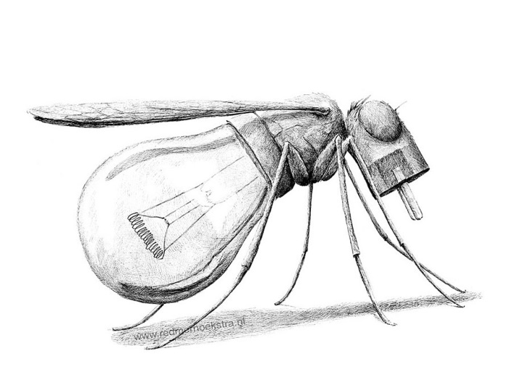
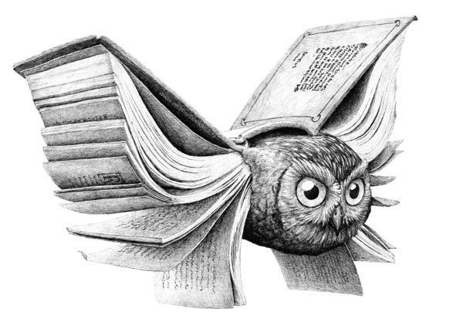

Option 5: Illustrate your best / craziest dream OR your worst nightmare
Media of your choice ( pencil crayon, collage, ink. Paint, marker, combination – anything goes! )
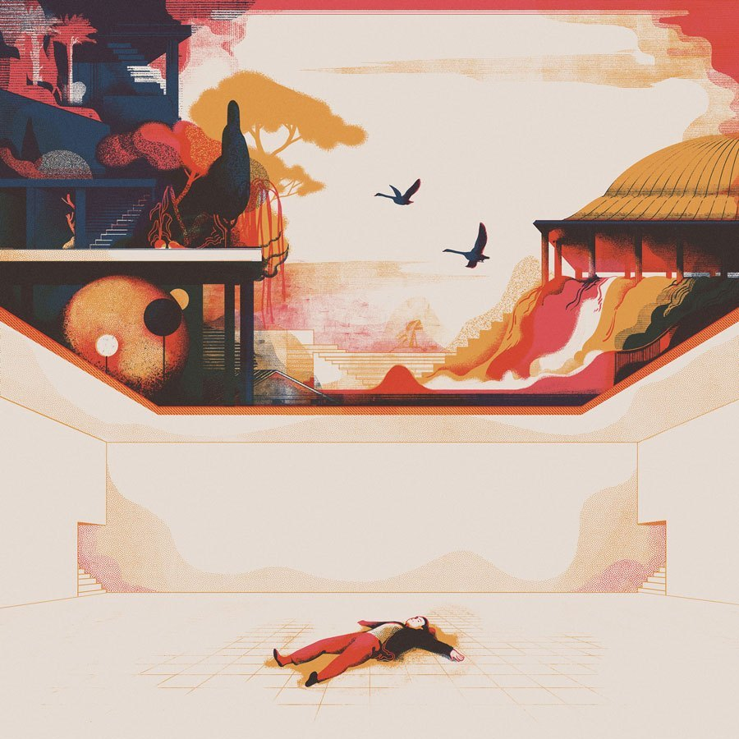
If using wet media I suggest completing the work on a separate piece of paper and then gluing it

